RESUME

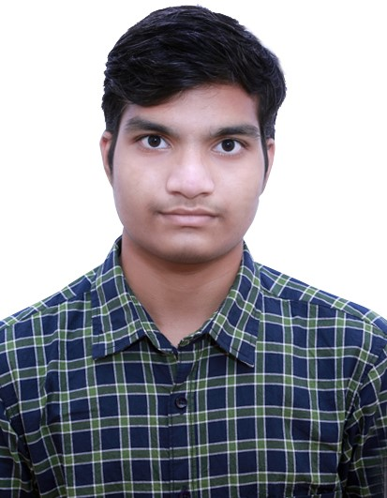

Maruthi Vamshi Krishna

Phone : xxxxxxxxxx

E-mail : xxxxxxxxxxx



Looking for a career which can sharpen my skills and knowledge where I can have a good scope for learning and implementing new technology.



|  |  |  |  |  |  |  |  |  |
| --- | --- | --- | --- | --- | --- | --- | --- | --- |
| **S.NO.** |  |  |  |  |  |  |  | |
| 1. | B. Tech | ACE Engineering college,  Hyderabad | Electronics &Communicati--on Engg. | March 2025 (Pursuing) | 81  (Till date) |  |  |
| 2. | Intermediate | Narayana Junior  CollegeHyderabad | Maths, Physics, Chemistry. | March 2020 | 88 |  |  | |
| 3. | S.S.C | Bhashyam High School Hyderabad | Maths, Science, Social Studies | March  2019 | 95 |  |

TECHNICAL PROILE

1. Operating Systems : Windows XP,VERSION 7 &11 and UBUNTU
2. Languages **:**  C,Python,java,HTML,CSS

**PROJECT REPORT**

* 1. Title : Blinking lights by using 555 timer IC
  2. Duration : August to September (2023)
  3. Purpose : Towards partial fulfillment for the award of my B.Tech,

Degree.

* 1. Material Used : Bread board , 555 Timer IC,LED etc.
  2. Team Size **:** THREE (3)

**ACHIEVEMENTS**

* + - Cisco C Certificate
    - Cisco Python Certificate
    - Sales Developer Virtual Internship

**STRENGTHS**

* Positive Attitude
* Self motivated
* Time Management

**WEAKNESSES**

* Have a difficulty in saying NO
* **OverThinking**
* **Perfectionism**

**HOBBIES**

* Listening to music
* Watching movies
* Playing Games

**DECLARATION**

It is hereby acknowledged that the information furnished above is true to my knowledge

**Place :** Hyderabad

**Date :** 07-02-2024

Maruthi Vamshi Krishna